eBoard — Test Coverage Gap Analysis
Compact Quantitative Report
HUB · eBoard (v1.0 + v1.1) · 2026-05-05

KEY METRICS
376 | 7 | 89 / 287 | 41 (10.9%) | Mobile (0%)
Total tests | Confluence pages | Tests v1.0 / v1.1 | Undocumented tests | Untested platform

1. Headline Findings
Finding | Quantity | Impact
v1.1 sub-feature with NO Confluence page (Fullscreen Table Formatting) | 41 tests / 0 pages | CRITICAL — spec missing
Documented platform with NO tests (View Board – Mobile) | 0 / 7 requirements (0%) | CRITICAL — tests missing
v1.1 cross-cutting topics tested but not documented | 11 topics | HIGH
v1.0 average requirement coverage | ~57% | MEDIUM
v1.1 average requirement coverage (documented topics) | ~90% | LOW
v1.0 TV/Fullscreen — strict spec coverage | 3 / 9 (33%) | MEDIUM
v1.0 Web View — direct spec coverage | 5 / 10 (50%) | MEDIUM

2. Coverage of Documented Requirements per Page
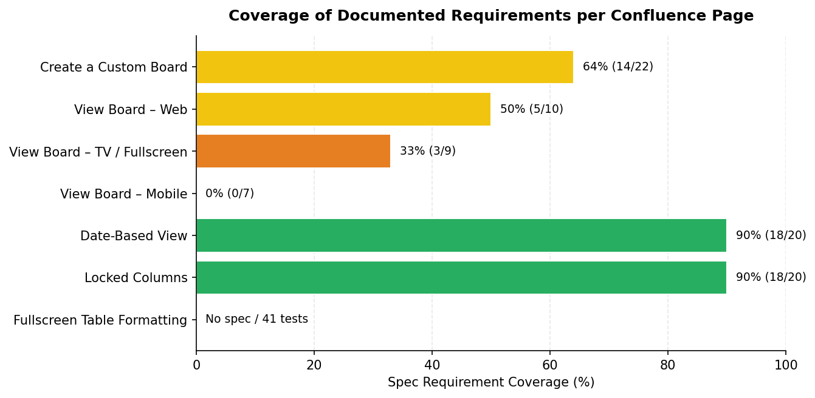

3. Where the Tests Are
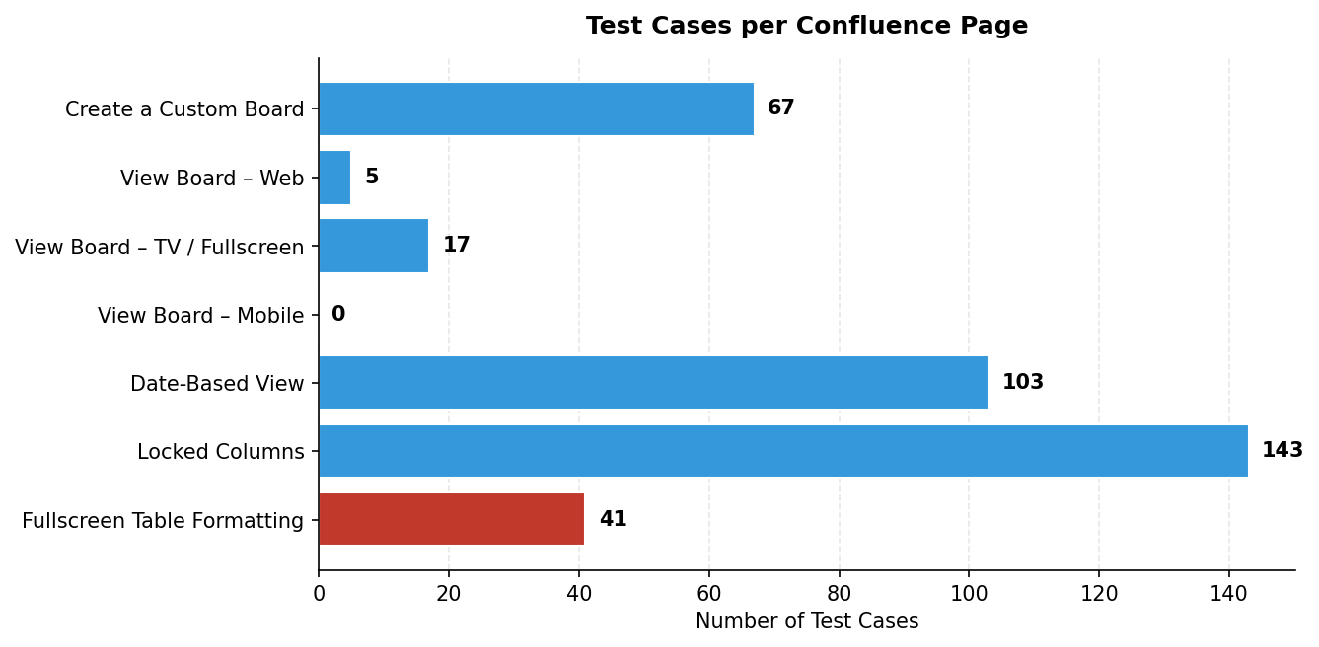
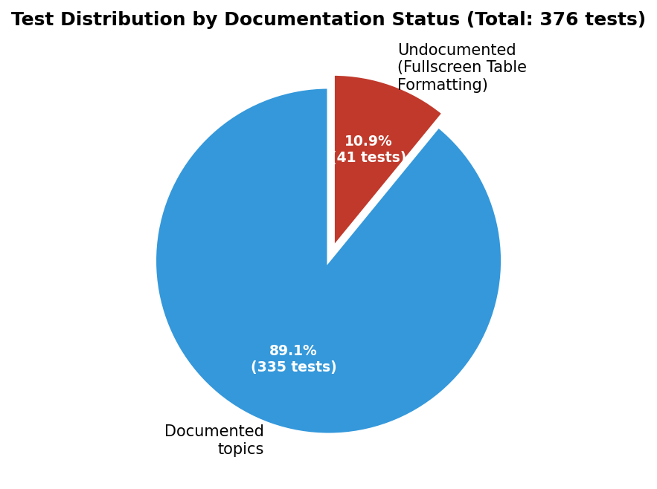

4. Coverage Matrix
Confluence Page | Ver | Spec items | Tests | Coverage | Verdict
Create a Custom Board | v1.0 | 22 | 67 | 14/22 (64%) | MEDIUM: gaps remain
View Board – Web | v1.0 | 10 | 5 | 5/10 (50%) | MEDIUM: gaps remain
View Board – TV / Fullscreen | v1.0 | 9 | 17 | 3/9 (33%) | HIGH: thin coverage
View Board – Mobile | v1.0 | 7 | 0 | 0/7 (0%) | CRITICAL: no tests
Date-Based View | v1.1 | 20 | 103 | 18/20 (90%) | LOW: well covered
Locked Columns | v1.1 | 20 | 143 | 18/20 (90%) | LOW: well covered
Fullscreen Table Formatting | v1.1 | 0 | 41 | N/A | CRITICAL: spec missing

5. Top 5 Gaps by Severity
# | Gap | Quantity | Type
1 | Fullscreen Table Formatting page does not exist | 41 tests, 0 pages | Doc gap
2 | View Board – Mobile: 0 tests | 0 / 7 reqs (0%) | Test gap
3 | v1.1 cross-cutting topics undocumented (audit, perms, network, concurrency, tz, a11y, bulk, reorder, confirms, "All" filter, empty-Date) | 11 topics | Doc gap
4 | View Board – TV: negative tests (no filter / no search / no 3-dot) and View Mode Toggle missing | ~5 missing reqs | Test gap
5 | Create Board: Shared Mode + UI/UX (step indicator nav, max 100 chars, max 10 columns, Checkbox) | ~6 missing reqs | Test gap

6. Action Plan (Priority-Ordered)
# | Action | Owner | Priority
D1 | Create "Fullscreen Table Formatting" Confluence page | BA | CRITICAL
T1 | Write View Board – Mobile test suite (~25-30 cases) | QA | CRITICAL
D2 | Add cross-cutting sections to v1.1 pages (11 topics) | BA | HIGH
T2 | Add TV/Fullscreen negative tests + View Mode Toggle (~6) | QA | HIGH
D3 | Unify "All" filter spec between Editing & Filtering and Fullscreen | BA | MEDIUM
T3 | Add v1.0 boundary + Shared Mode + step indicator tests (~10) | QA | MEDIUM
D4 | Document edge cases (rapid toggle, today-empty, atomic save) | BA | MEDIUM
T4 | Web View: lazy-load, last-updated, Header/Sidebar collapse (~5) | QA | LOW
D5 | Unify naming Sidebar/Side and Header/Top across pages | BA | LOW

Methodology: spec items counted by enumerable bullet/sub-bullet requirements per Confluence page; covered items = tests directly verifying that requirement; cross-cutting topics counted separately.
— End of report —

